|  |
| --- |
| PICK-A-PATH  Manual  Dummy Street  Phone: 111-111-1111  Email: dummy@email.com |



## General Information

## The general information section of the manual presents a general overview of the program and the organization of this manual.

## 1.1 System Overview

## The main goal of Pick-A-Path is to have an adaptive environment molded by user decisions in order to experience basic story game development. This software will be a GUI for a user to make logical decisions within a base environment given. This can be then used to make a number of different possible outcomes for their game. The user will have two different modes to develop their game, a developer mode and a game mode, to make this software as user-friendly as possible.

## 1.2 Organization of the Manual

## This manual is organized into four parts: General Information, System Summary, Getting Started and Using the System.

## General Information explains the purpose of the system and provides information about the manual.

## System Summary provides an overview of the system’s hardware and software requirements, user access levels and the system’s action during any contingencies.

## Getting started explains how to run the system in order to use it. It summarizes the features of the system menu and introduces the two modes of game development provided by the system.

## Using the system explains in detail how to work with Pick-A-Path to create games. It explains every feature of the system and how to use it for game development.

## System Summary

## 2.1 System Configuration

Pick-A-Path will operate only on Desktop or Laptop computers; it currently will not support mobile devices. It will be coded and ran using primarily Java.

The hardware needed for the game should not be very demanding. The user will need to meet the minimum hardware requirements to run our software:

* CPU: Intel Core i3-3210 3.2 GHz / AMD A8-7600 APU 3.1 GHz or equivalent
* RAM: 2GB
* GPU (Integrated): Intel HD Graphics 4000 (Ivy Bridge) or AMD Radeon R5 series (Kaveri line) with OpenGL 4.4*
* HDD: At least 1GB for game core and other files

**2.2 User Access Levels**

Everyone who wishes to create a text-based game can use this system.

**2.3 Contingencies**

In case of power outages, the system just retains the last saved memory of the game file and does not auto-save. The system does not require an Internet connection in order to be used.

## Getting Started

## 3.1 Running the program

## Pick-A-Path does not contain

## Using the System

## 4.1 Editor Mode

## The Editor mode of Pick-A-Path is where the game is created. This section explains all the features of the system and how they can be used to create a game.

## 4.1.1 Canvas

## The figure below shows the starting window of the system. The grey area is known as the Canvas and it is where the game is created.

## image

## 4.1.2 Make a Box

## The boxes in Pick-A-Path represent the scenarios that you want to create. Follow the following steps to create a box.

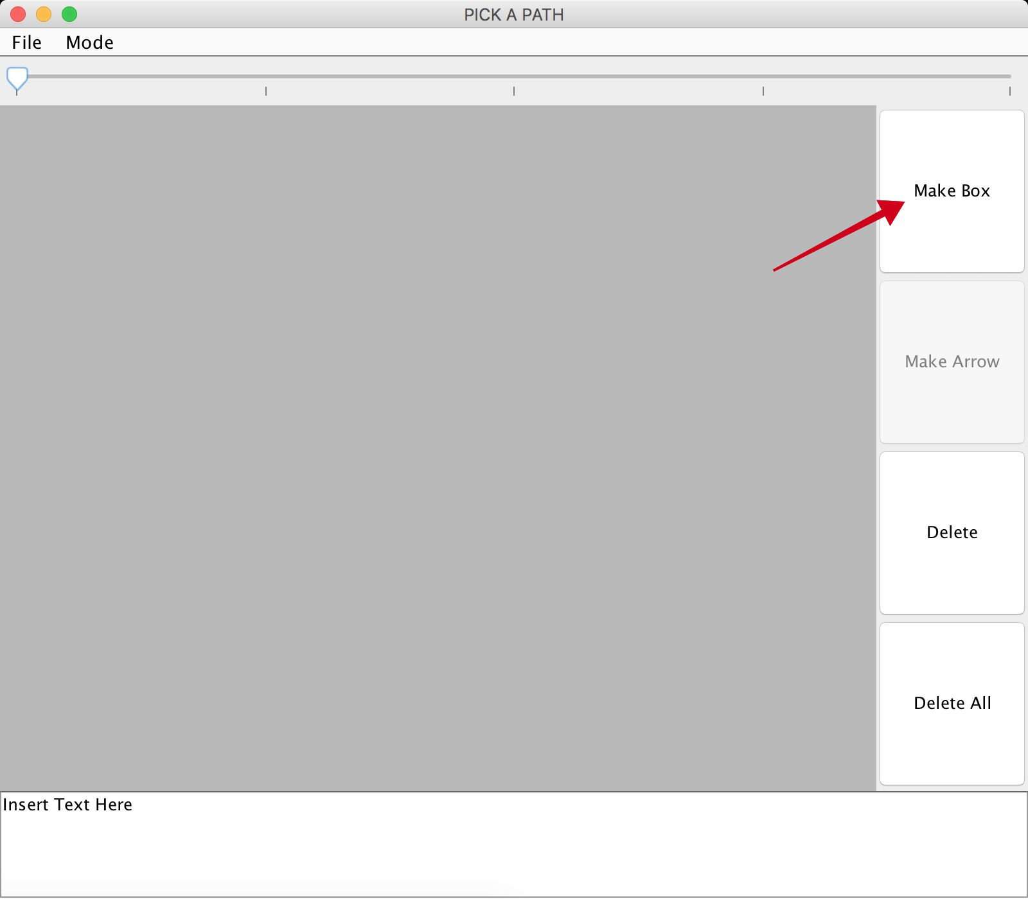

Step 1: Click on the Make Box Button

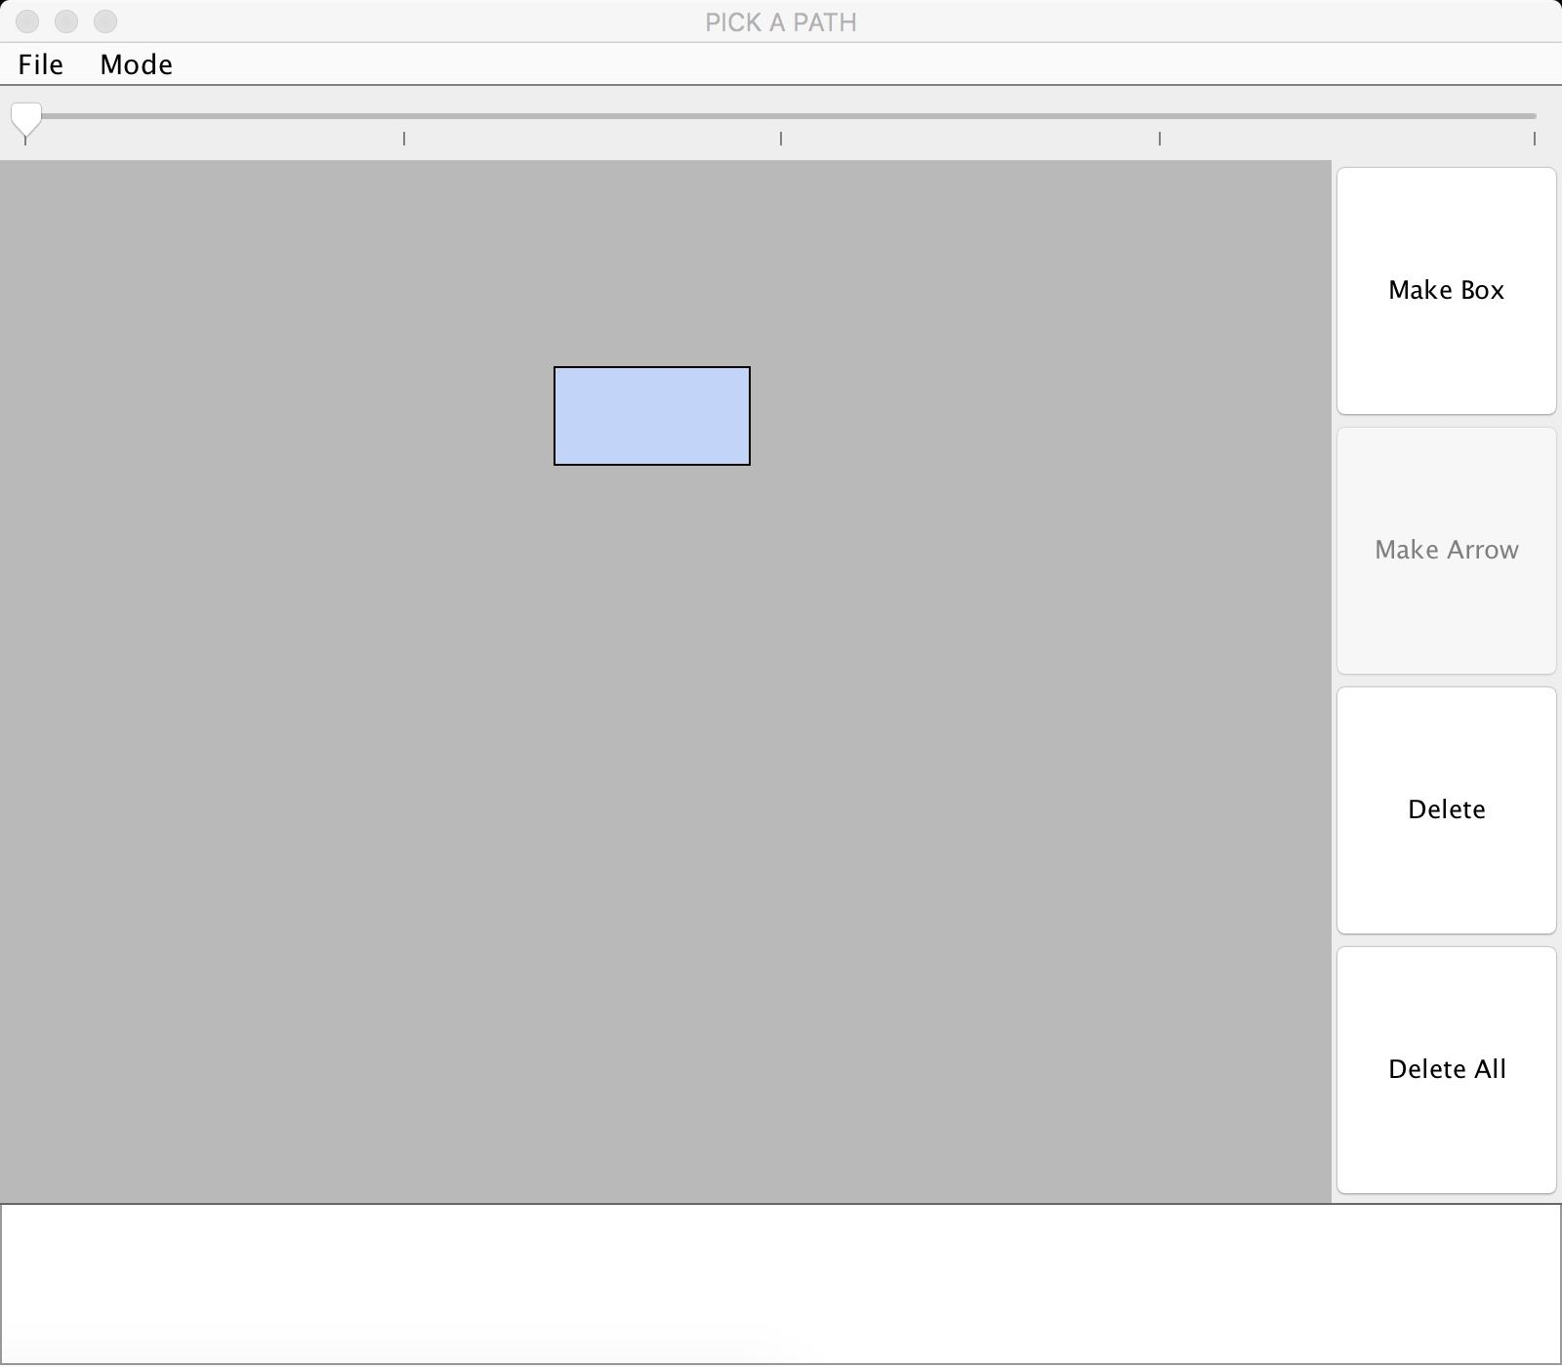

You will see a box created on the Canvas each time you click the “Make Box” Button.

## 4.1.3 Select a Box

## A box can be selected by clicking on the box. A selected box is going to appear in a darker shade of blue as compared to the rest of the boxes.

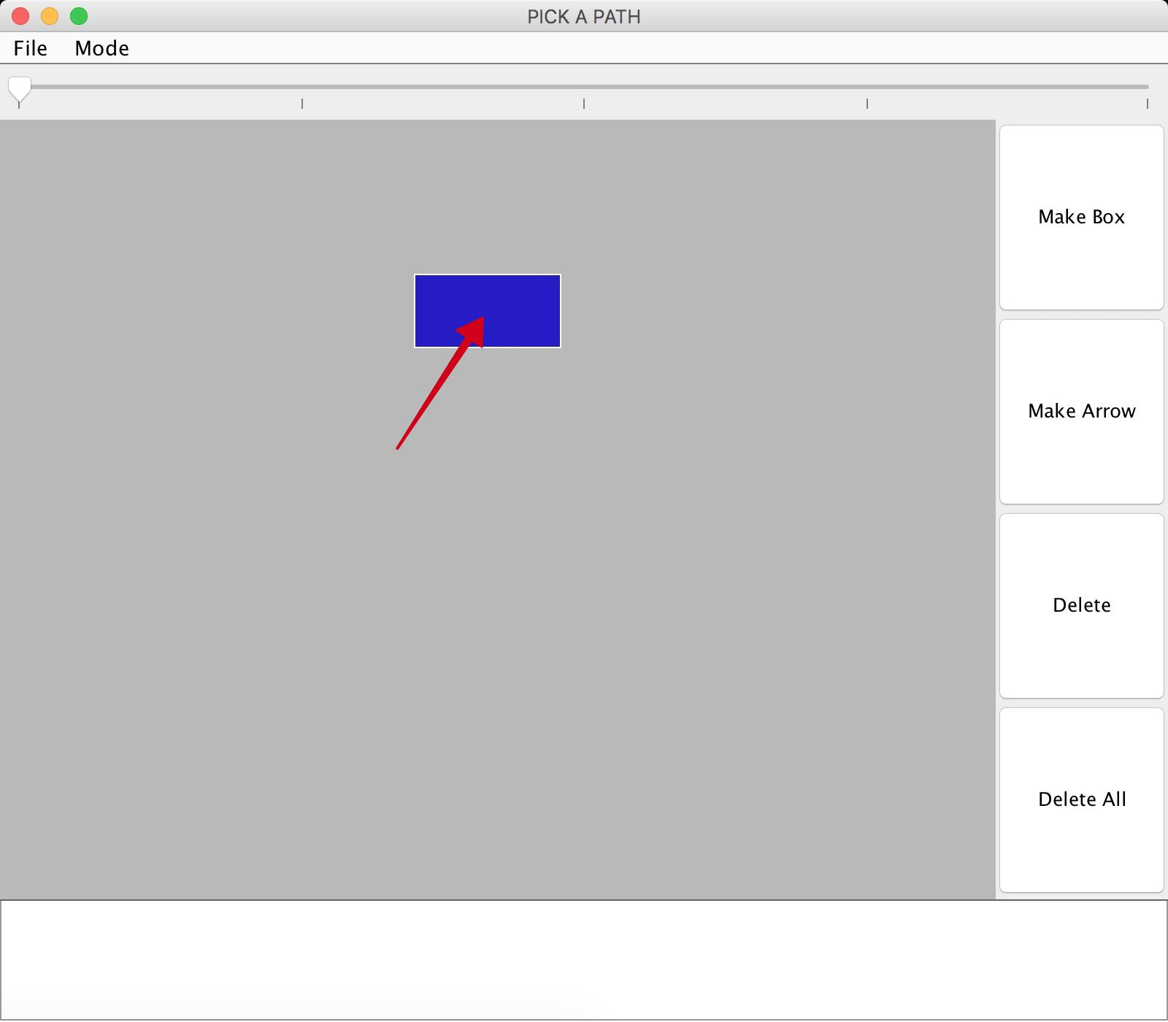

## 4.1.3 Make an Arrow

The Arrows allow the boxes to be connected in a logical flow. These arrows represent options, to move forward from one scenario (box) to another. Follow the following steps in order to make an arrow.

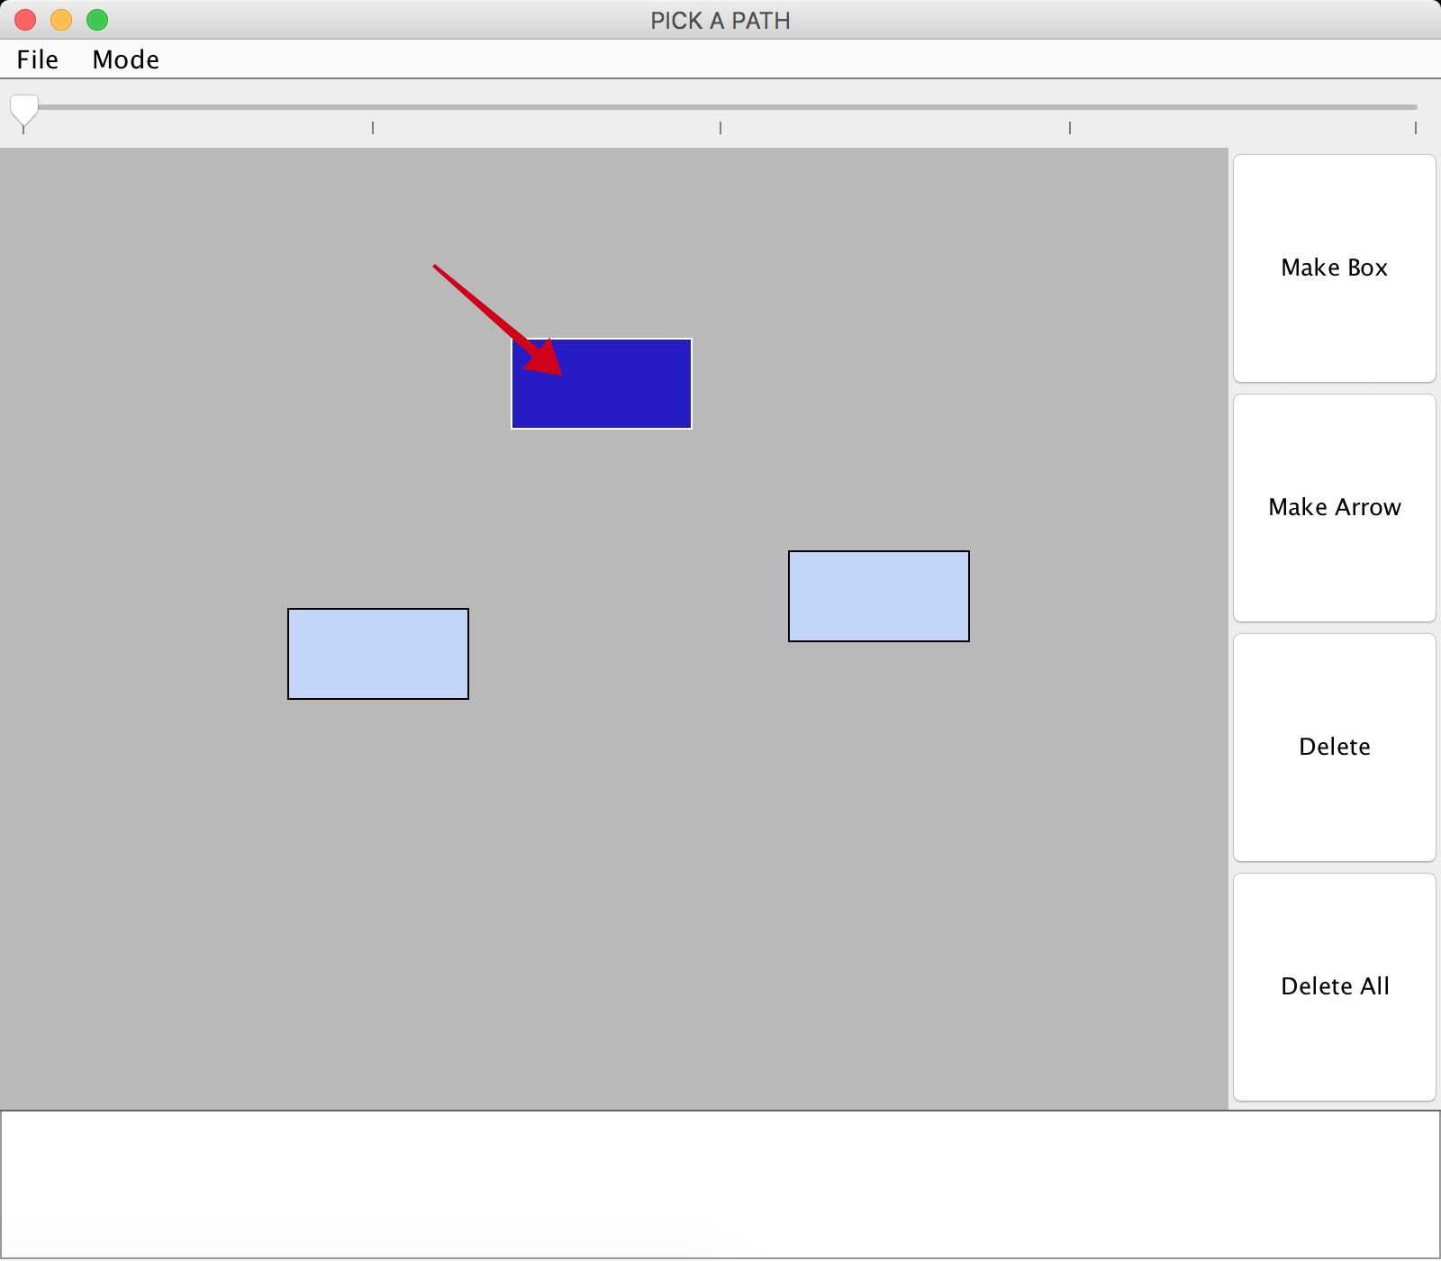

Step 1: Select the box from where the arrow needs to originate.

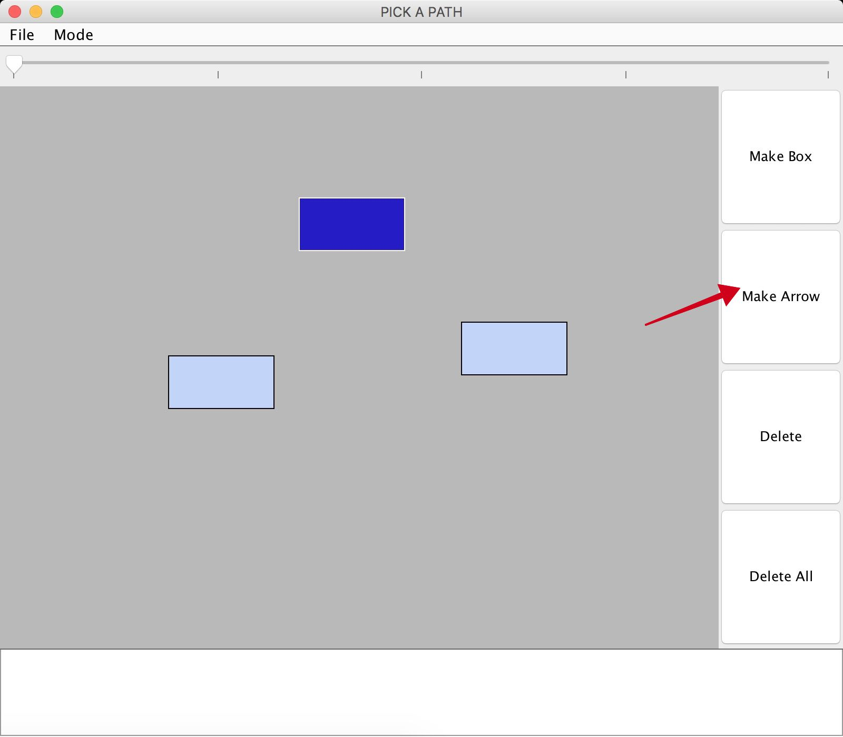

Step 2: Click on the Make Arrow Button

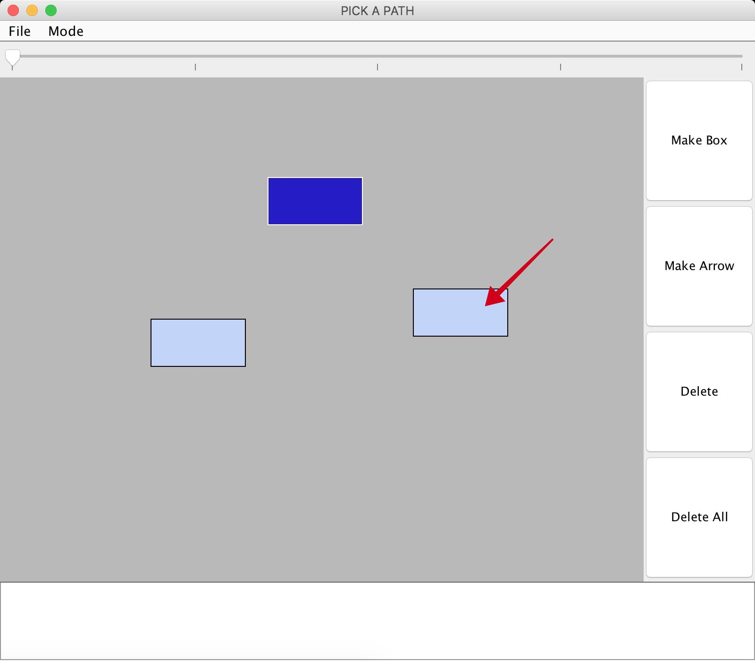

Step 3: Select the box that the arrow needs to connect to.

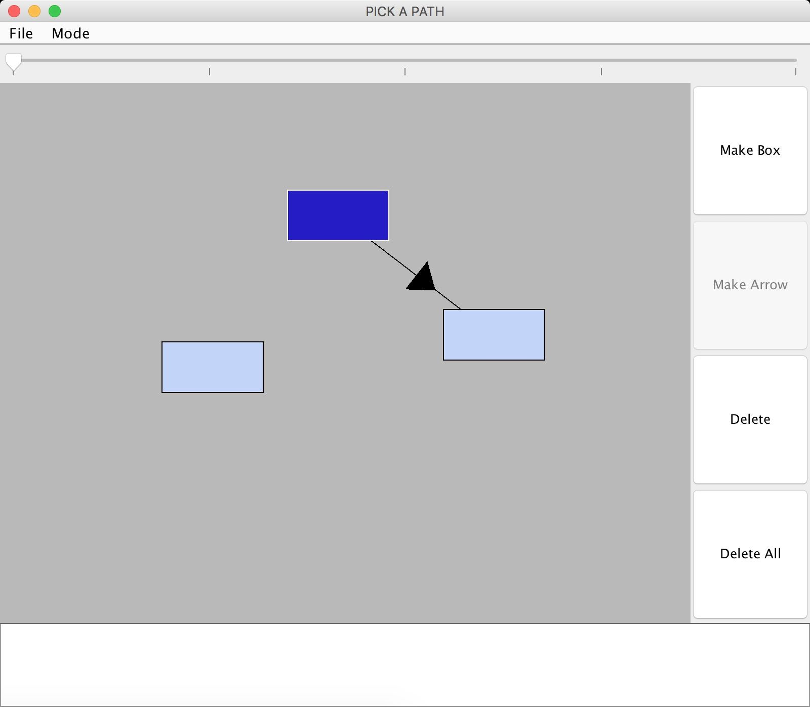

You will be able to see the arrow connecting the two boxes.

## 4.1.4 Select an Arrow

## An Arrow can be selected by clicking on the arrow. A selected arrow is going to appear white in color as opposed to all the black arrows.

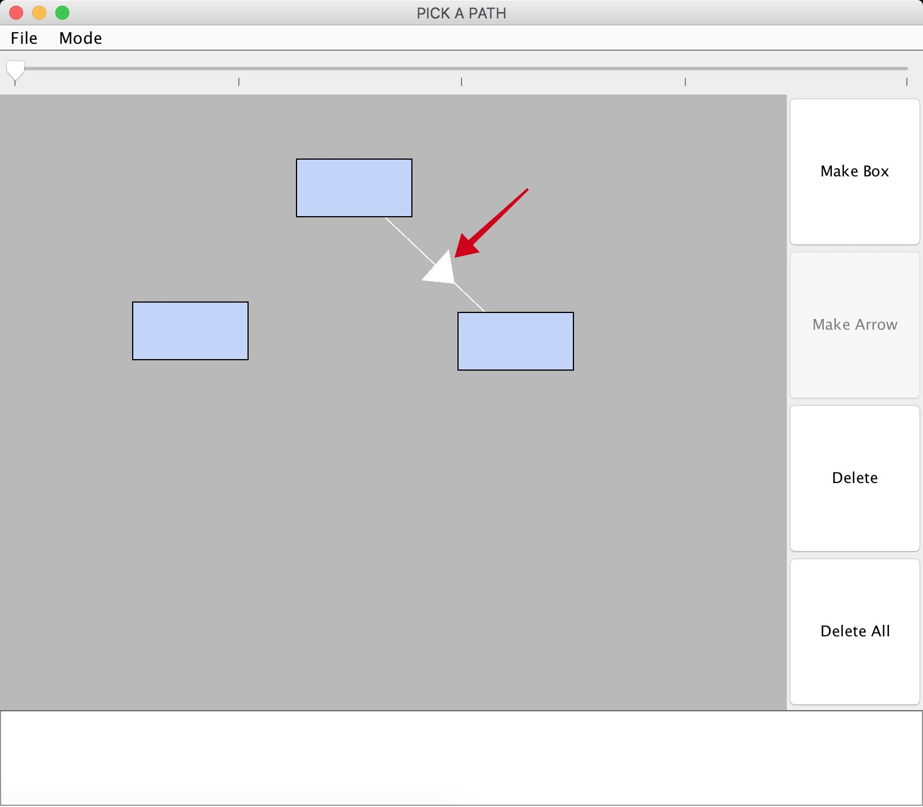

## 4.1.5 Add text to box and arrow

## After knowing how to create boxes and arrows, you can start creating your own game. The story that needs to be told is presented in the form of text in the boxes and arrows. The texts in the boxes are the scenarios and the texts in the arrows are the options to move from one scenario to another. You click on the respective box or arrow, and add text in the white space available at the bottom of the window for each of them. While the text for the boxes is represented in each box, the text in the arrows is shown as options in the player mode.

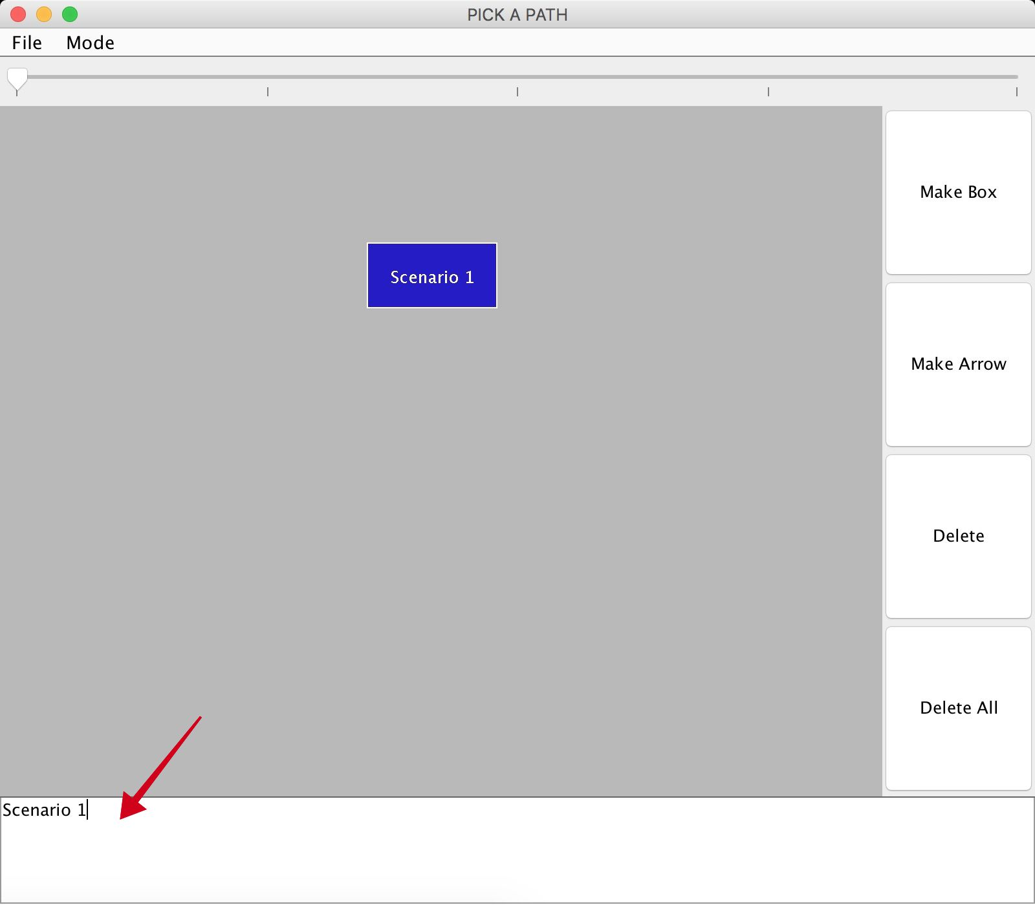

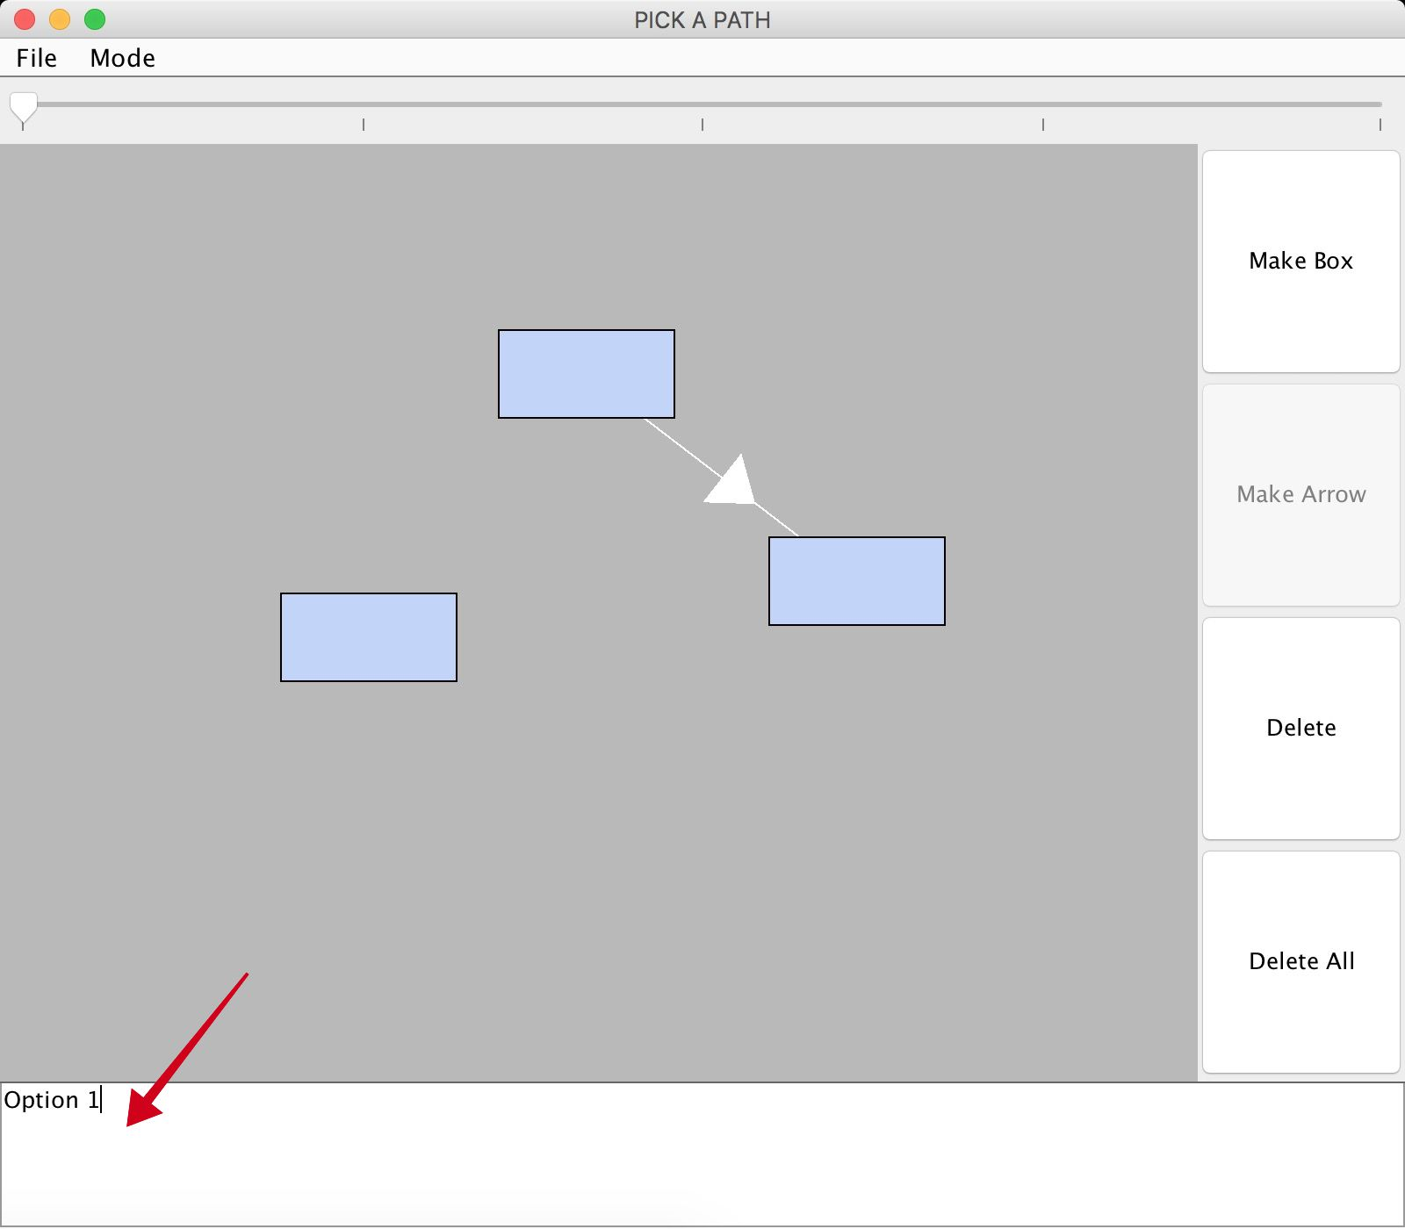

## 4.1.6 Delete

To delete a box or an arrow, you need to select the respective item and click on delete.

When the delete button is used for an arrow, it only deletes an arrow. However, when the delete button is used for a box, it deletes the box along with all the incoming arrows to the box.

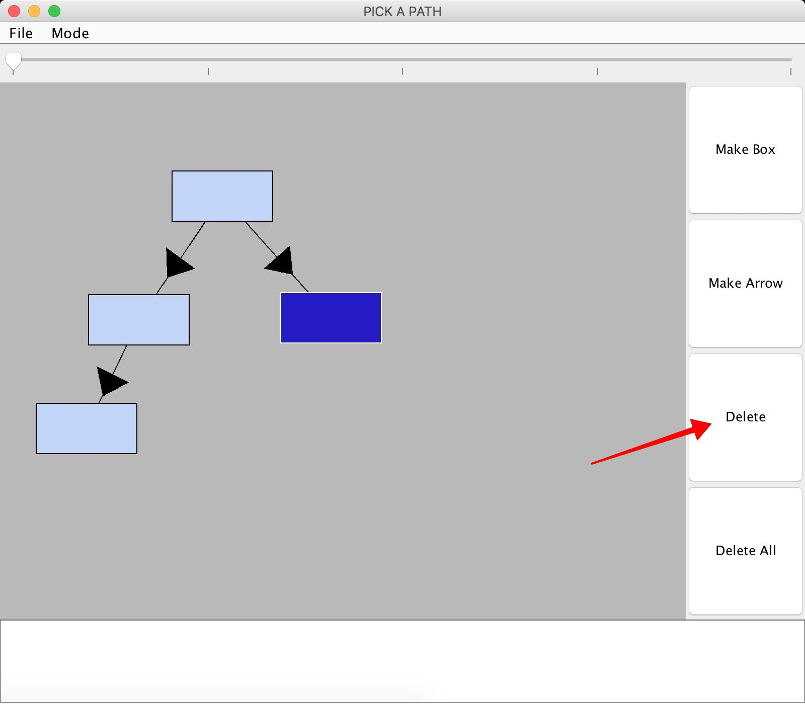

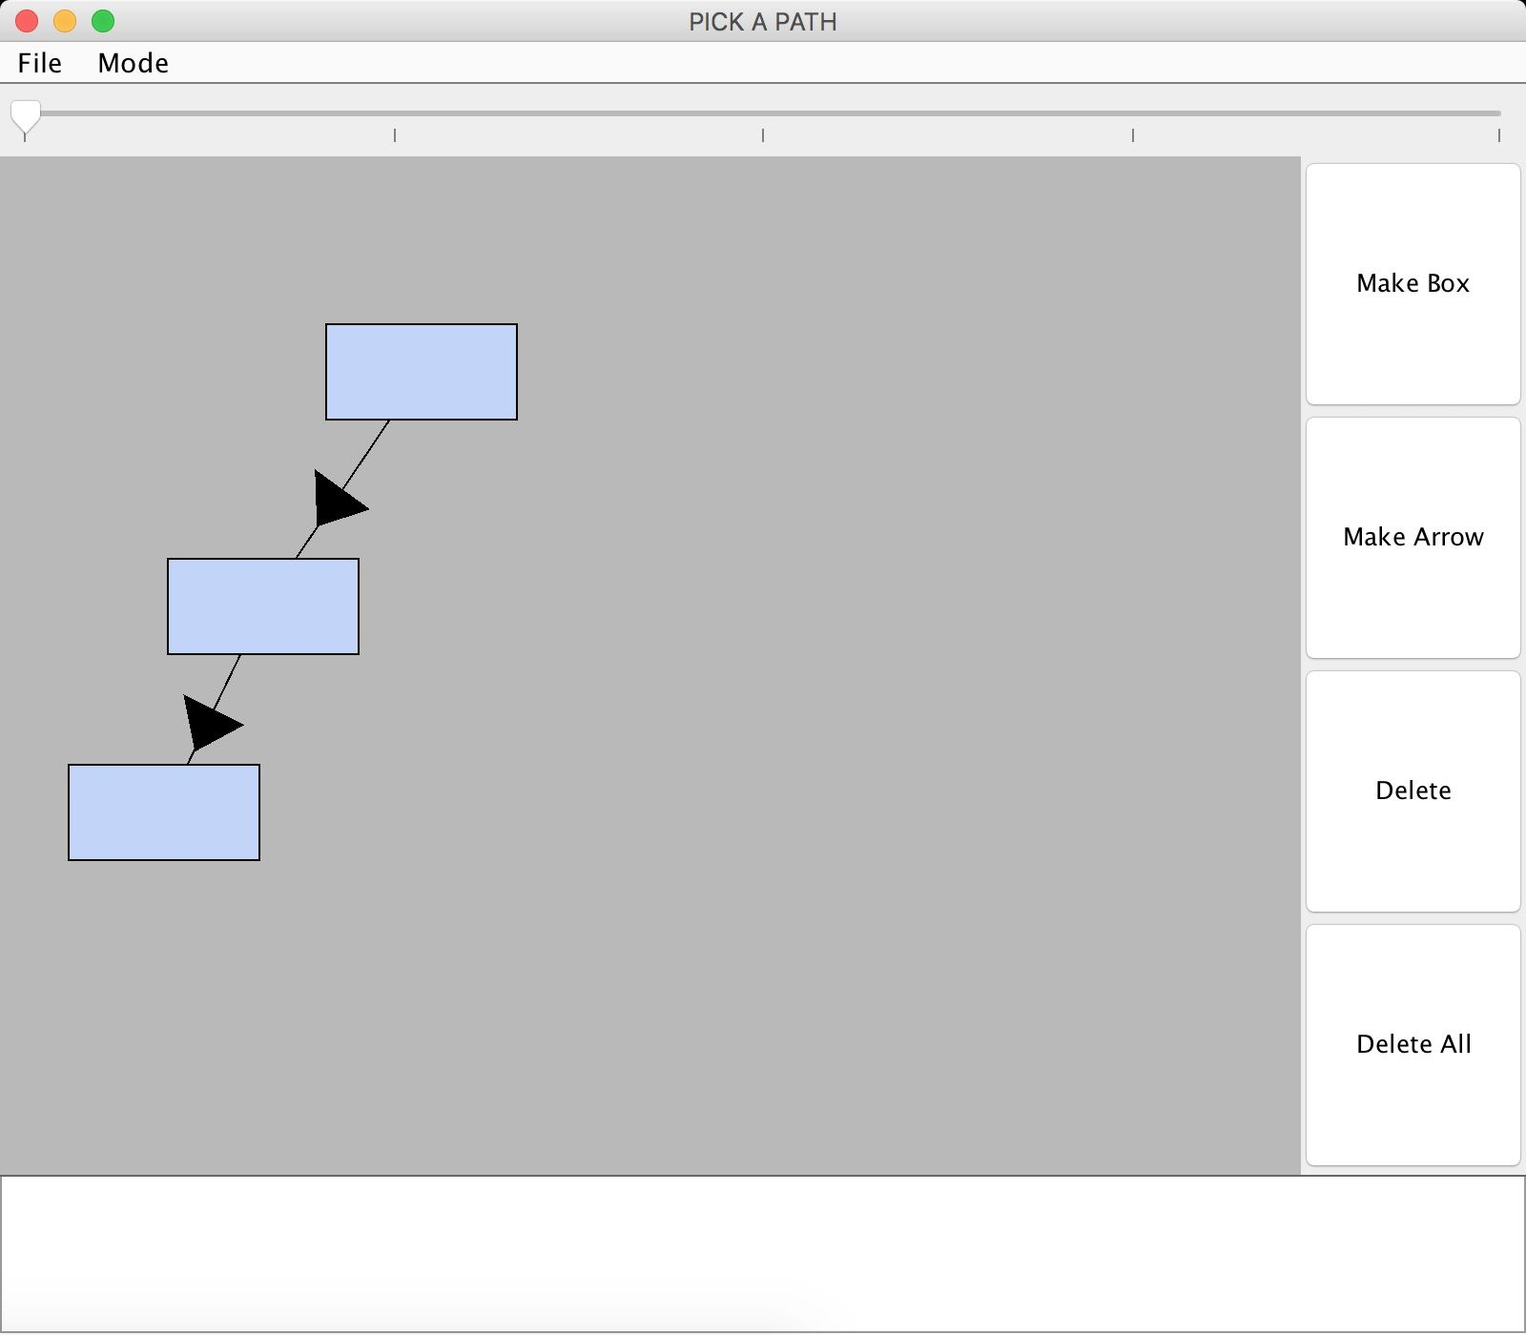

## 4.1.7 Delete All

The Delete All button clears the entire game once in for all.

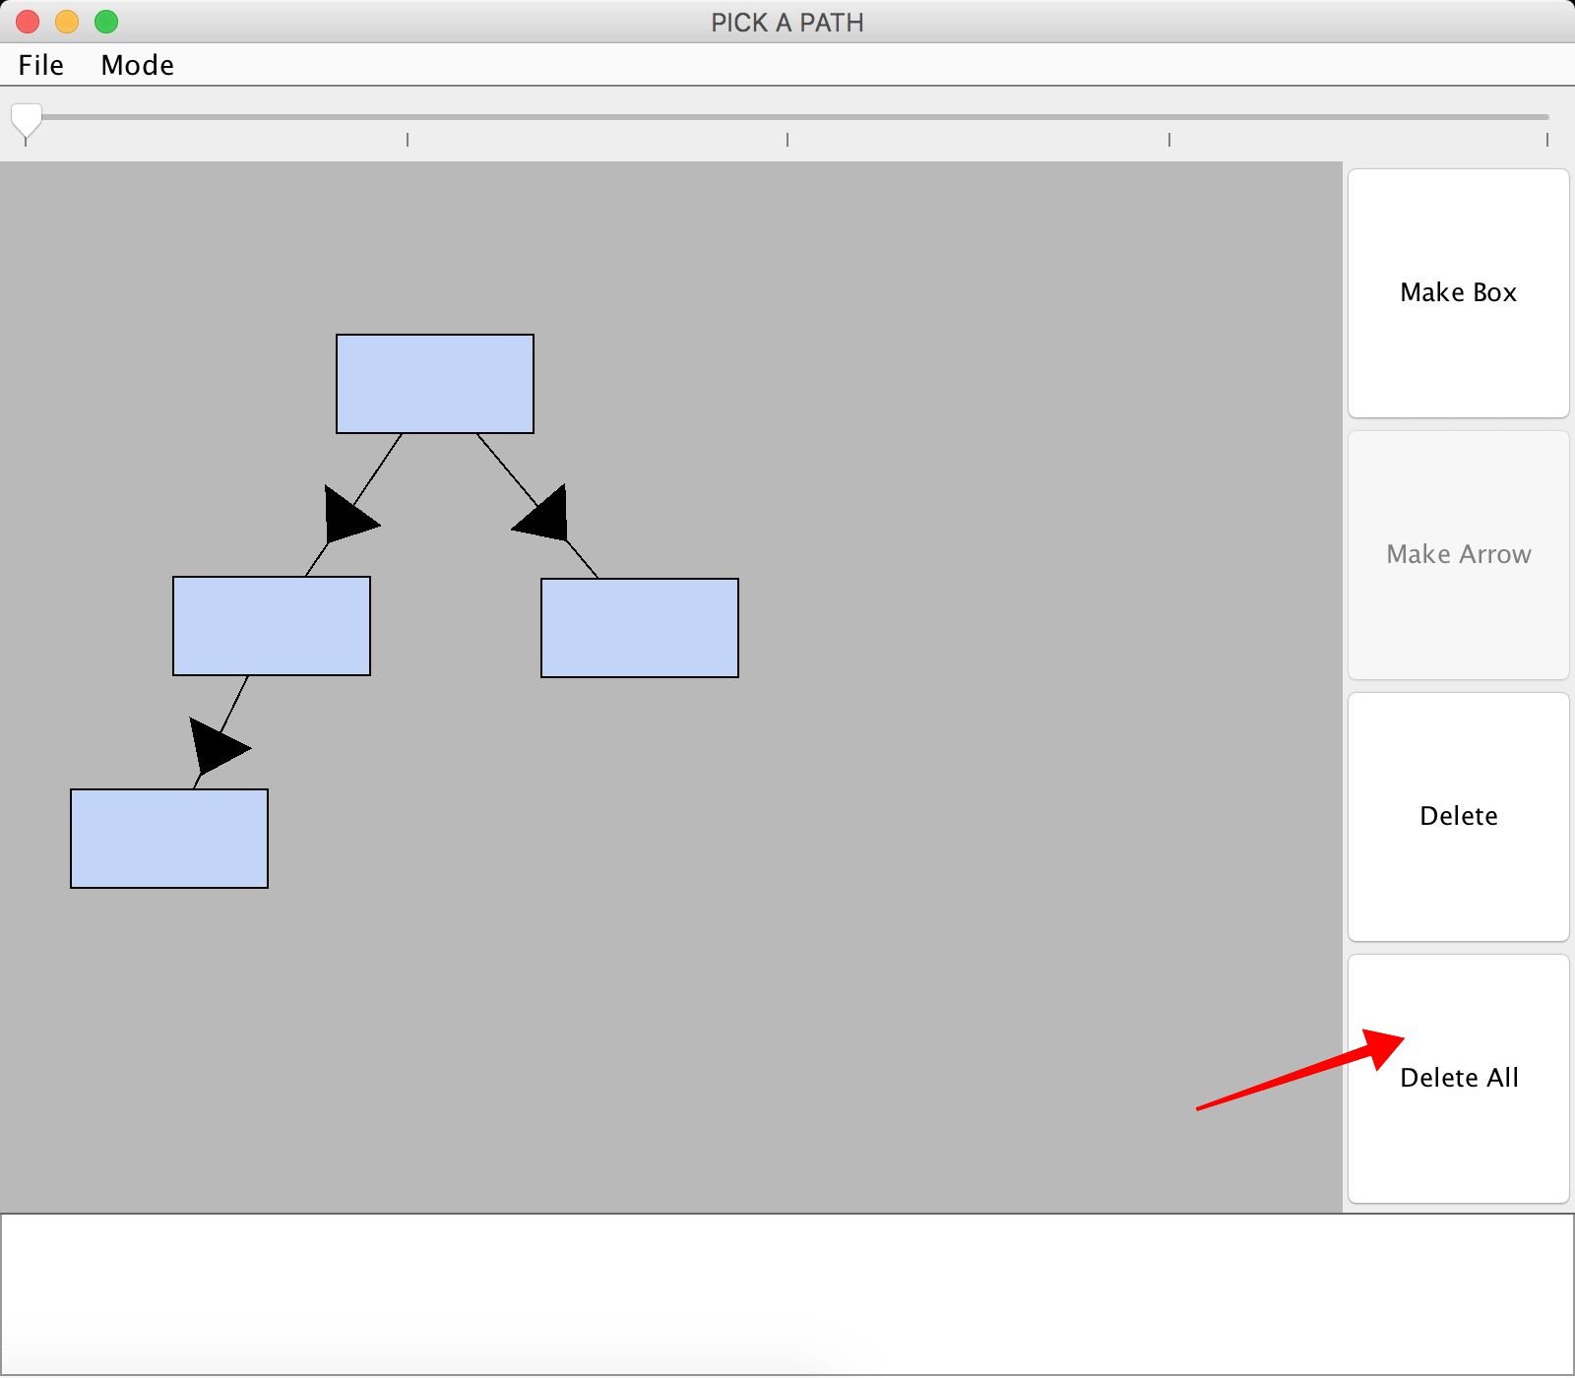

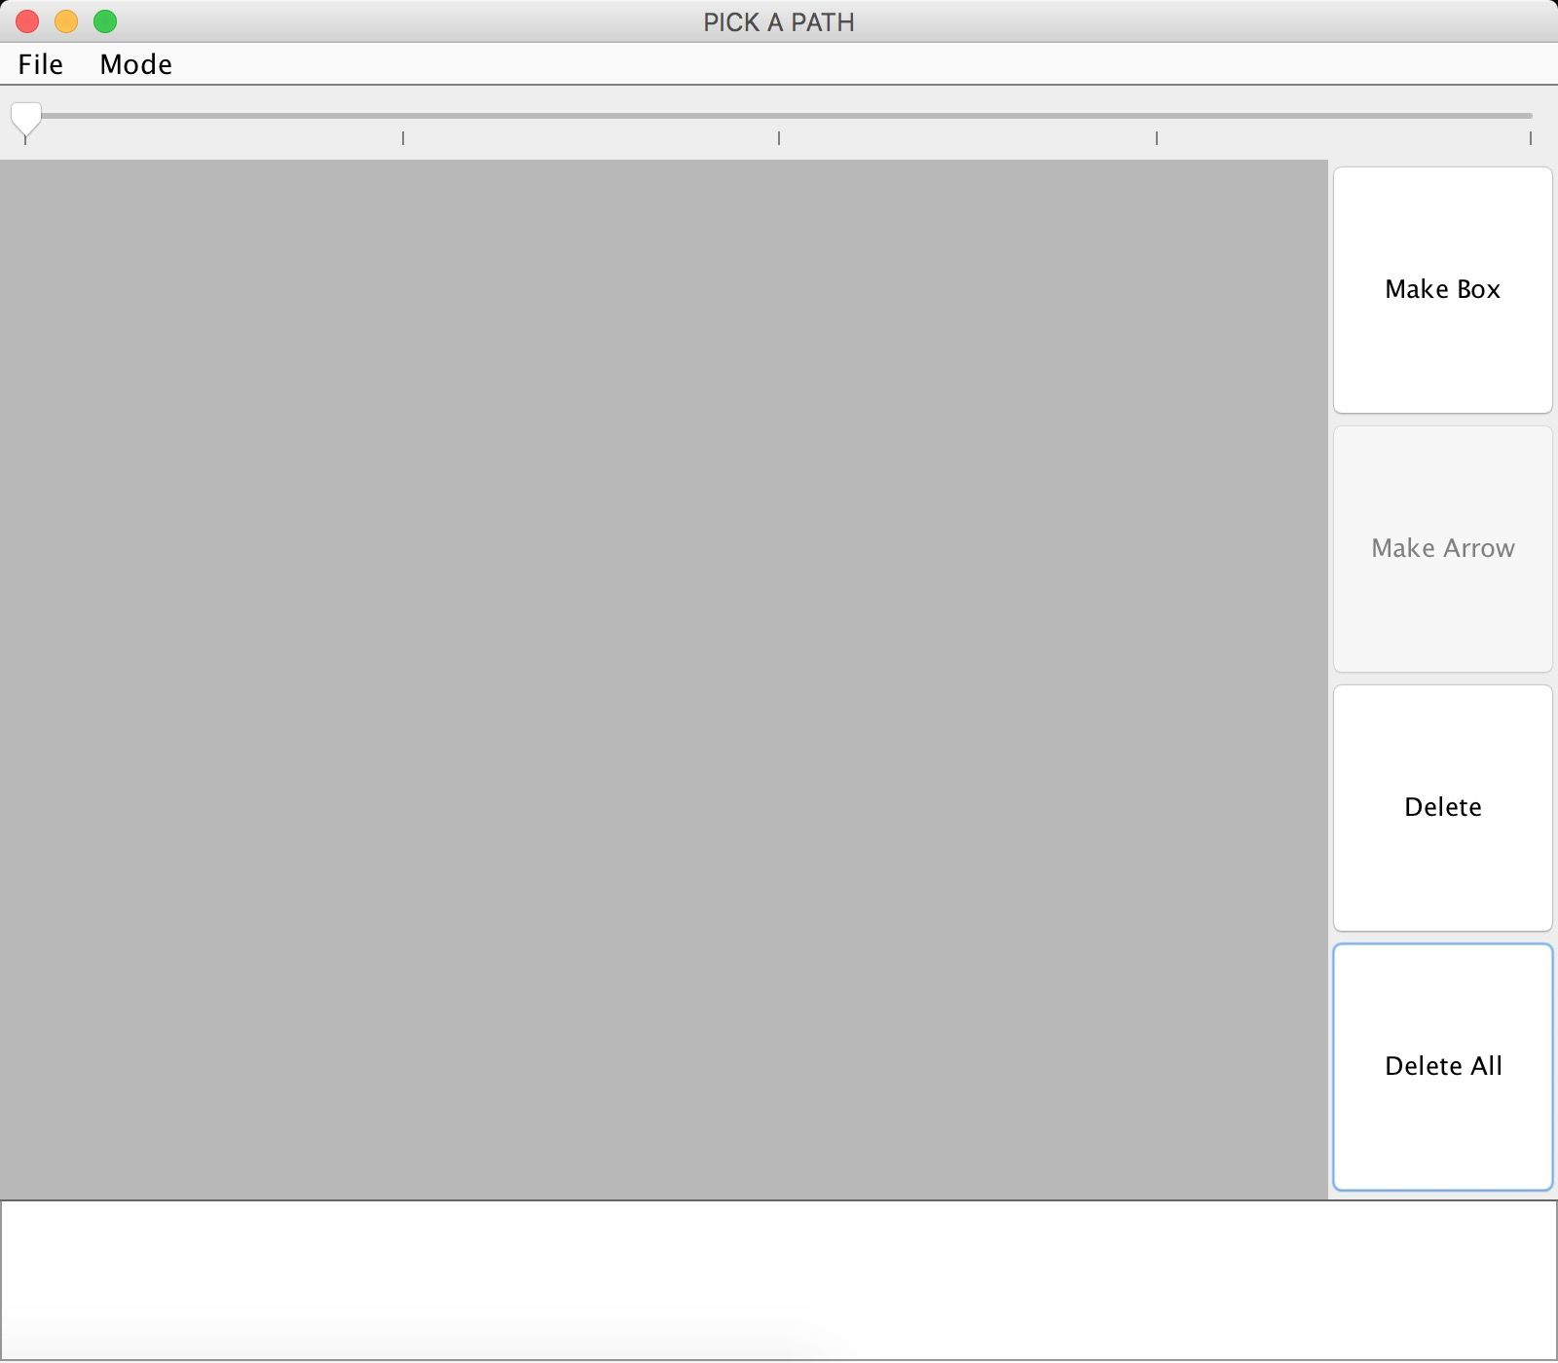

## 4.1.8 Slider

The top of the window contains a slider that can zoom in and out to get a overall or specific view of the game.

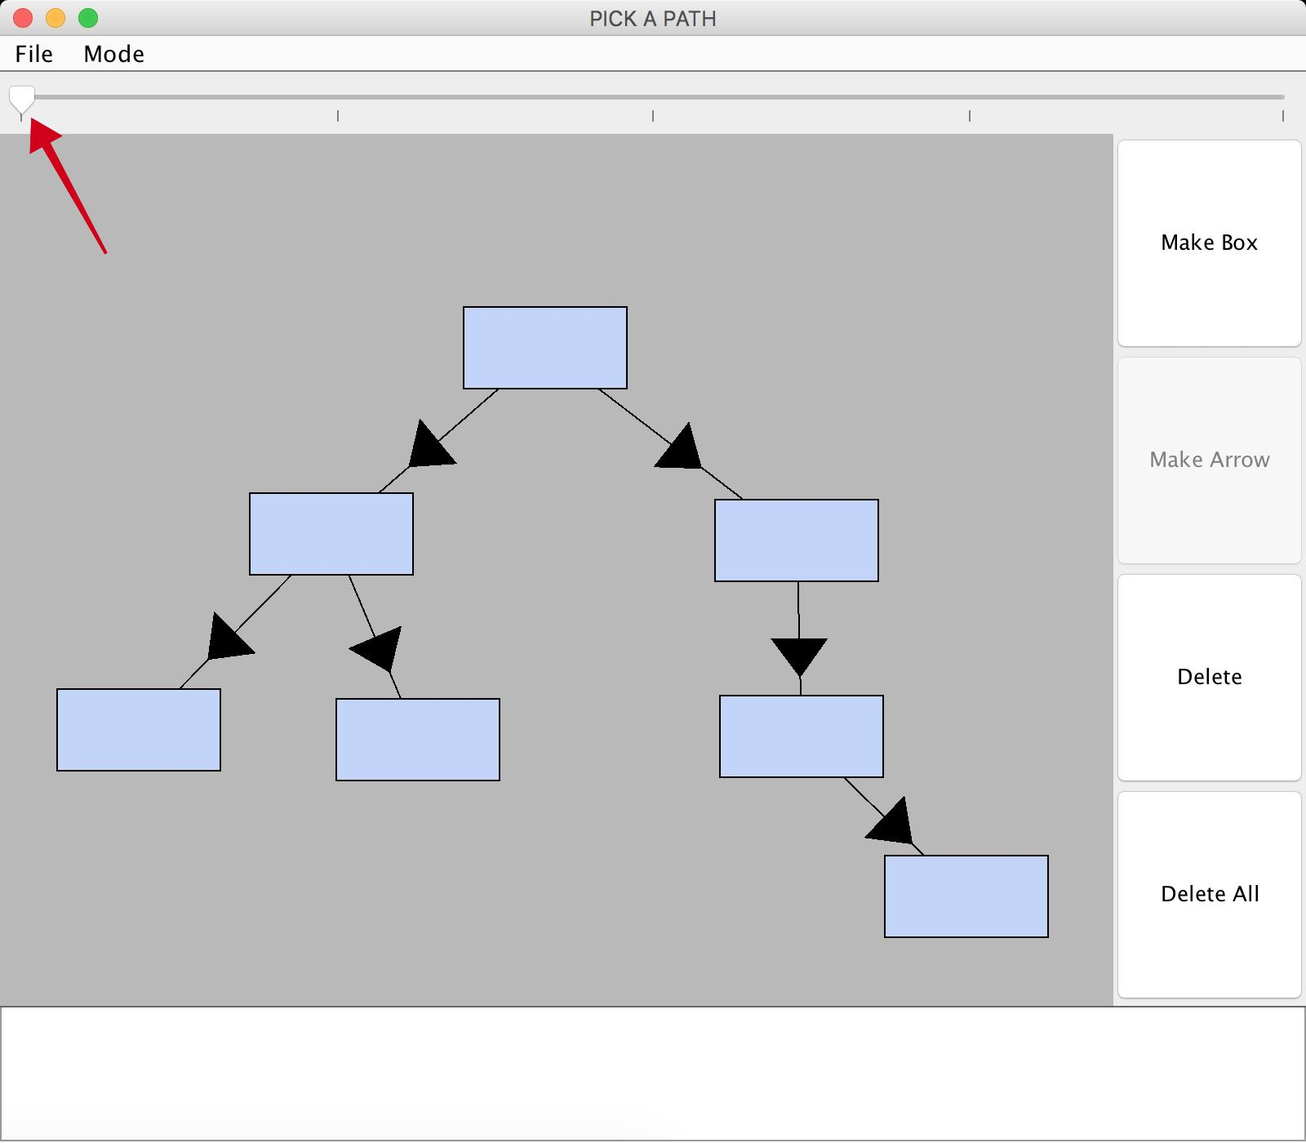

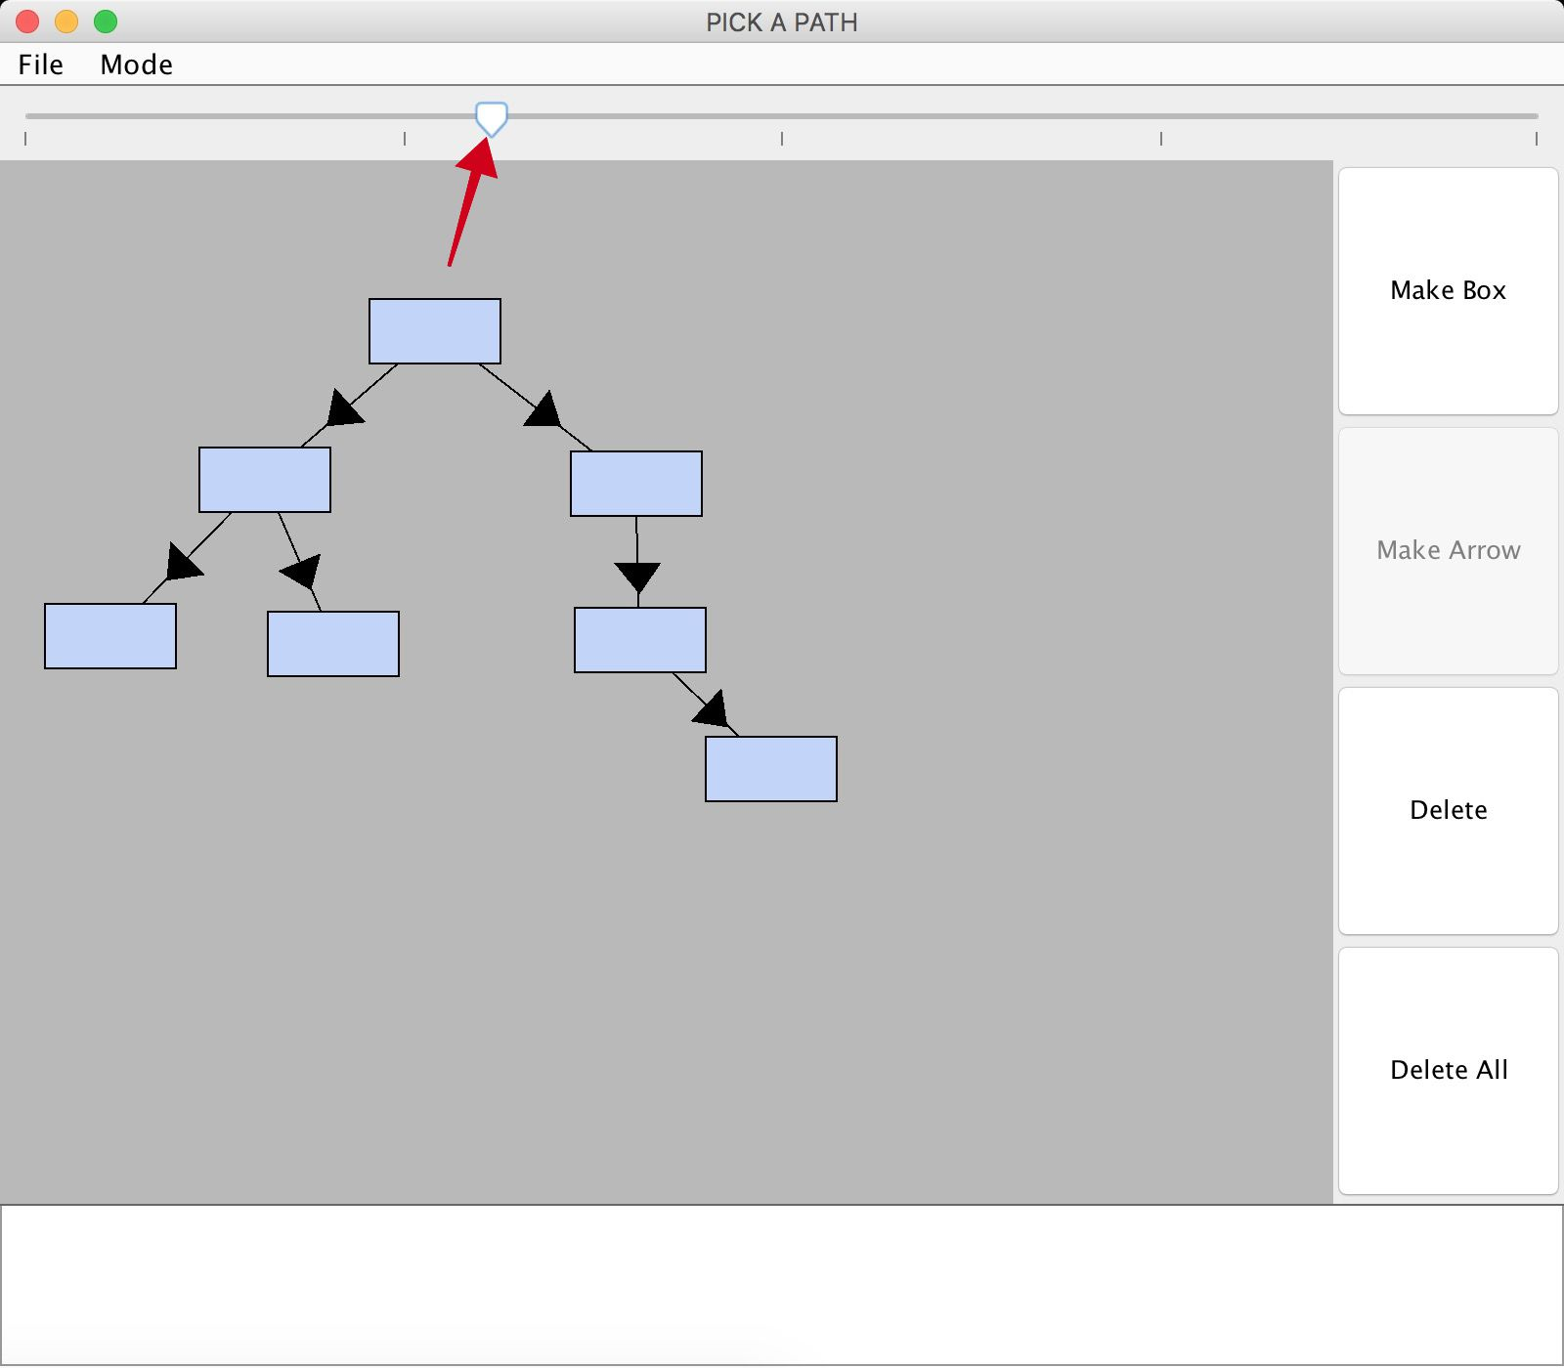

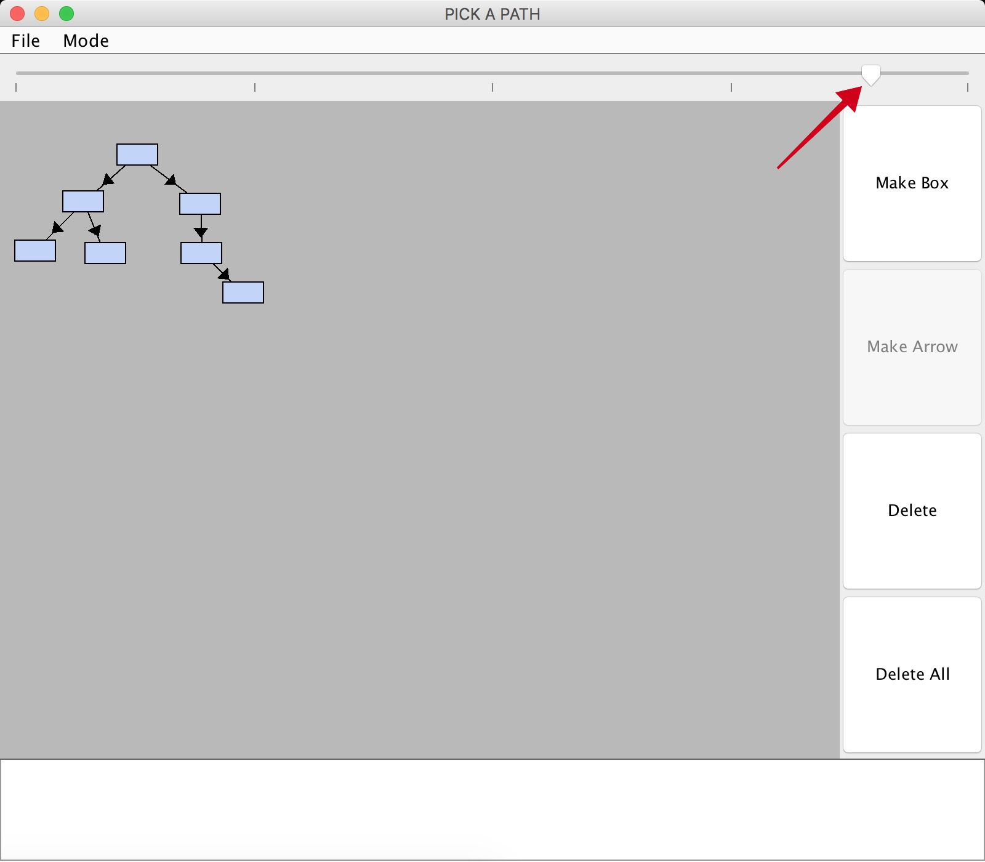

## System Menu

